With reference to https://www.cityu.edu.hk/ss_posed/index.aspx?lang=en (Tabs are bolded)
Make sure it is accessible on mobile
Bonus: accessible website guidelines https://www.ogcio.gov.hk/en/our_work/community/web_mobileapp_accessibility/promulgating_resources/handbook/

For all pages
Top: large banner with ss department logo and button to switch language (Chinese and English)
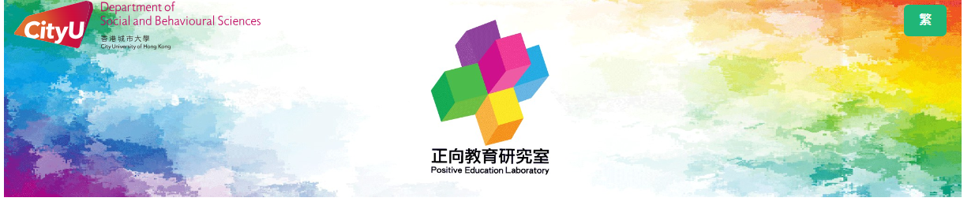
Side: Tab panel (buttons to other tabs) (if possible, add FB and IG icon to link to our social media pages)
DEI@WORK facebook: https://www.facebook.com/profile.php?id=61557433298431&mibextid=ZbWKwL
Instagram: https://www.instagram.com/dei_at_work?igsh=MTMydGIxdGkzbXpz

Bottom: hyperlink to CityU website
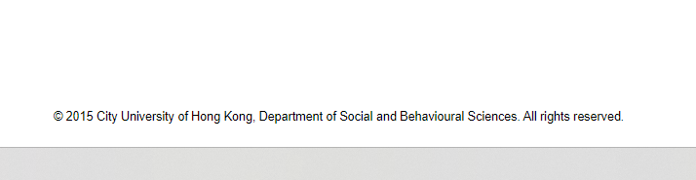

Content: both in Chinese and English (both versions same structure on different content)

Home
Middle: Static text (switching picture and news not necessary)

News
Updated at backend
Items to be pressed on, with update time on the right
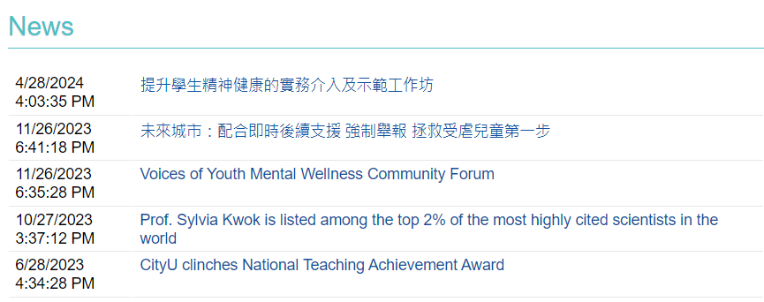
OR
Automatically with IG post @dei_at_work (preferred)
Showing the IG preface directly

About Us
Text
Hyperlink to download a pdf (about our project)
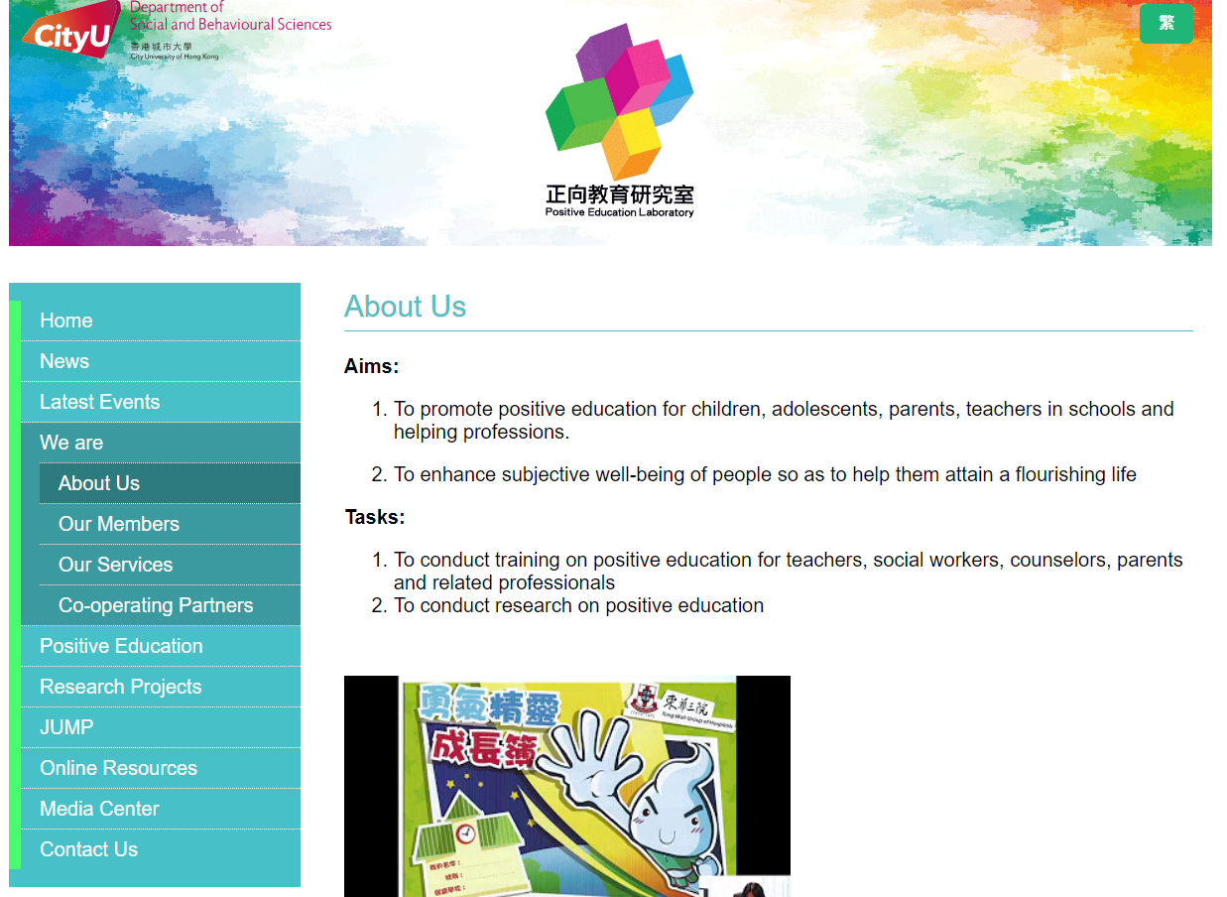
About Us -> Our Services (subtab)
Text

About Us -> Co-operating partners (subtab)
List 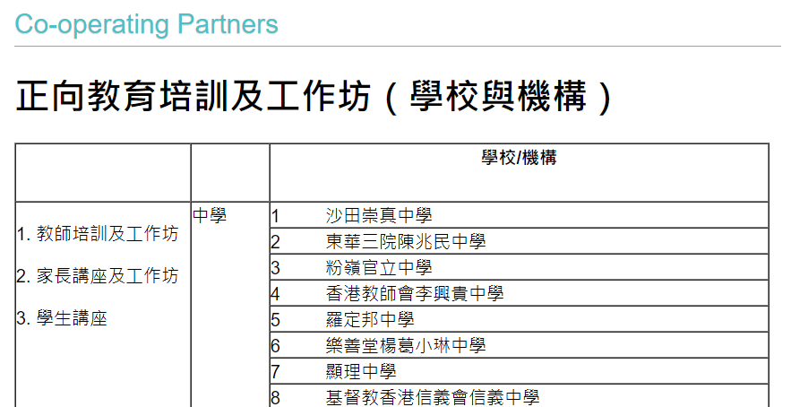
OR
Company logos (TBC)

What is DEI
Text with images

Media coverage
Updated at backend
Items to be pressed on (hyperlink to other media article), with update time on the right (similar to News)

Contact Us
Text
Bonus: Add FB and IG icon and link directly to our social media

